**1.     Select all columns from the employee table.**

**2.     Select unique department names from the 'department' table:**

**3.     Select employee names and salaries from the 'employee' table, ordered by salary in descending order:**

**4.     Select products with a price between £100 and £500 from the 'product' table:**

**5.     Select orders made by employees in the 'IT' department by joining 'purchase' and 'employee' tables:**

**6.Select products with names containing 'Chair' using a wildcard:**

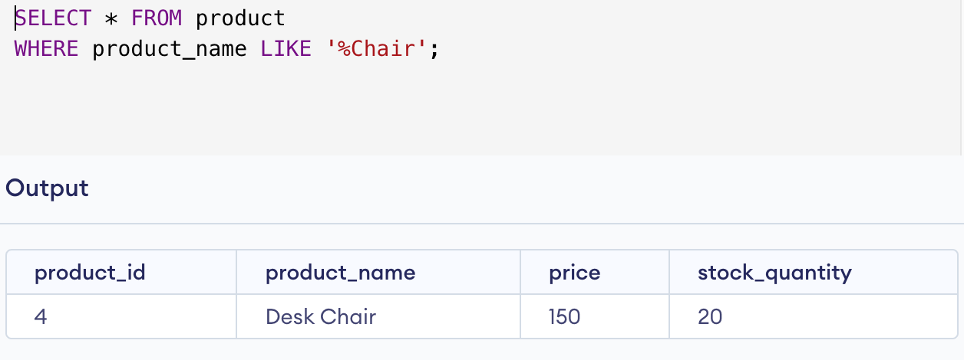

**7.     Select orders made by employees with IDs 1, 3, and 5:**

**8.     Select the average salary of all employees:**

**9.     Select employees hired after '2022-03-01' with a salary greater than £60000:**

**10. Select departments with more than 1 employee, counting the number of employees in each department:**

